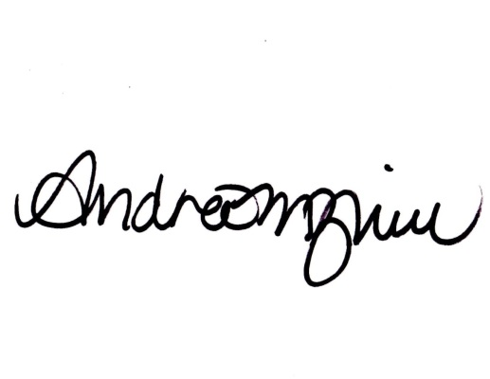

Signature:

This certificate is awarded to:

_______________

For completion of 3 credit hours of professional development in:

Subitizing Webinar

The Learning Garden for teachers

Date: 03/20/2018

